Private First Class Frank J. Kvasnosky
Military Police, 1st Infantry Division
Omaha Beach

Draft Registration

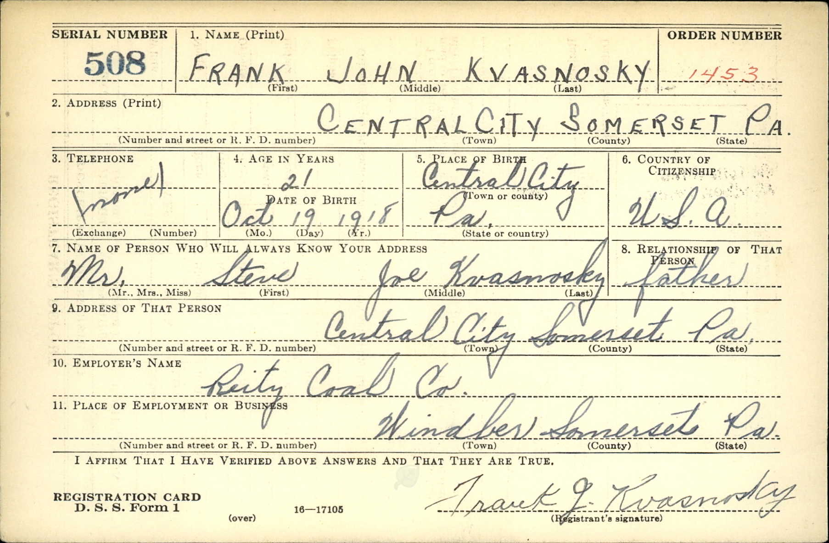

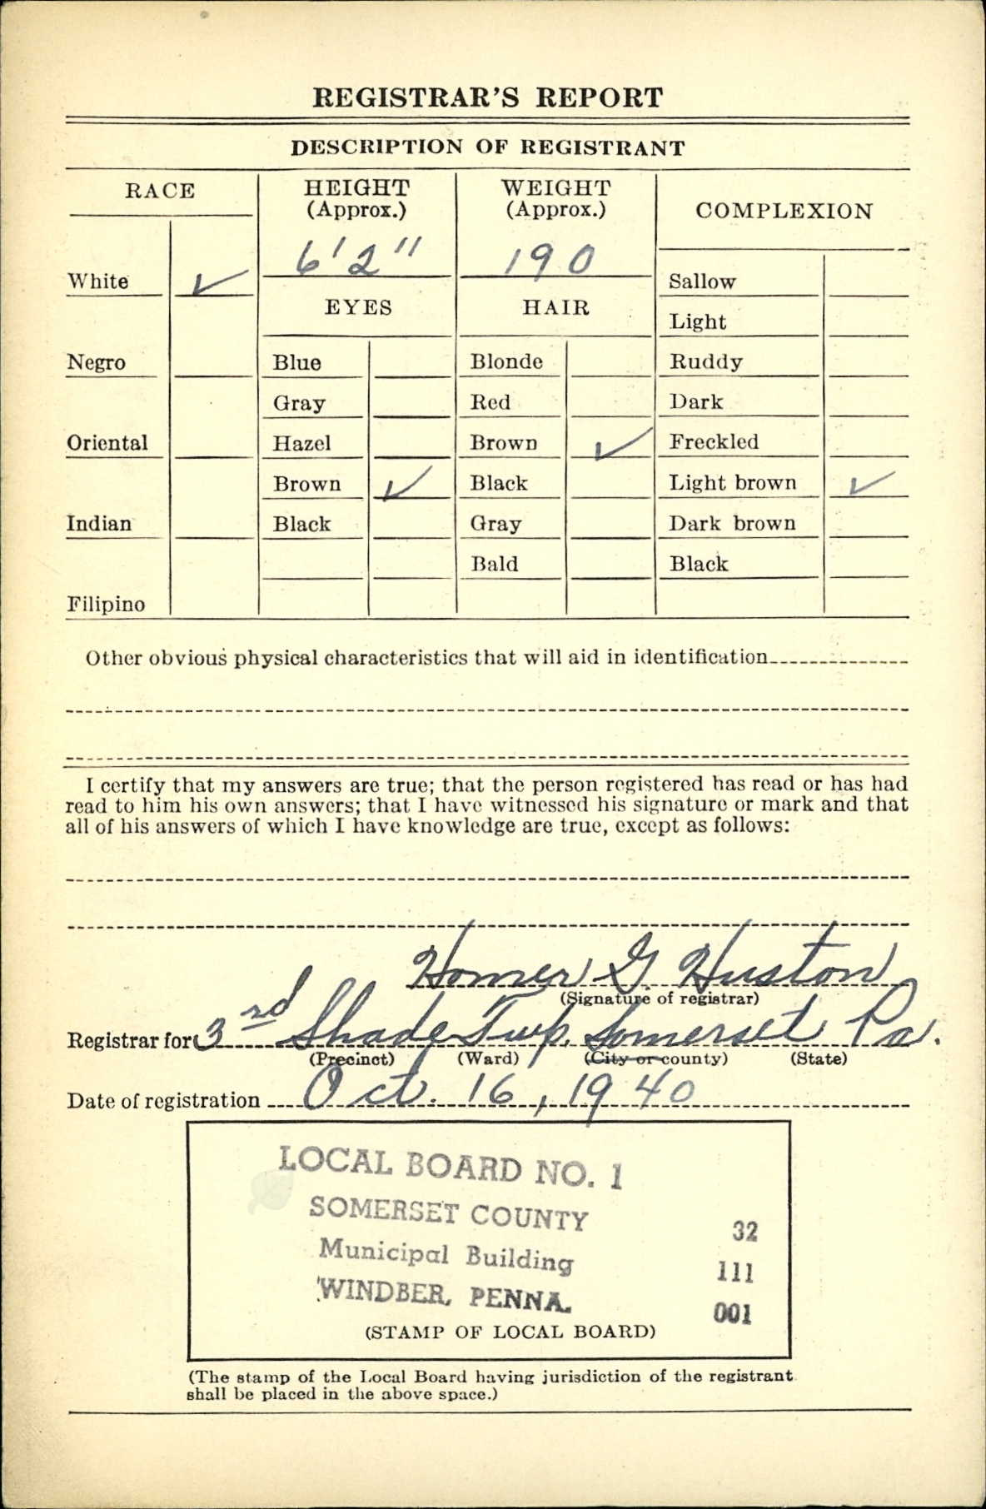
Pension Application
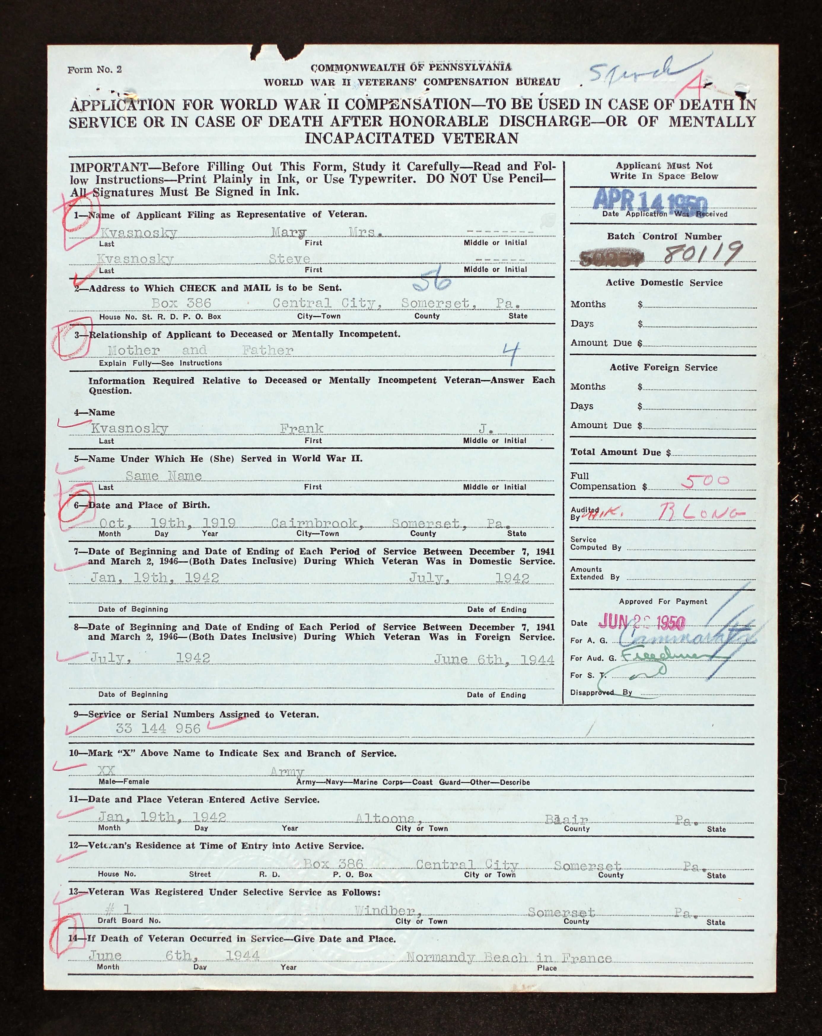

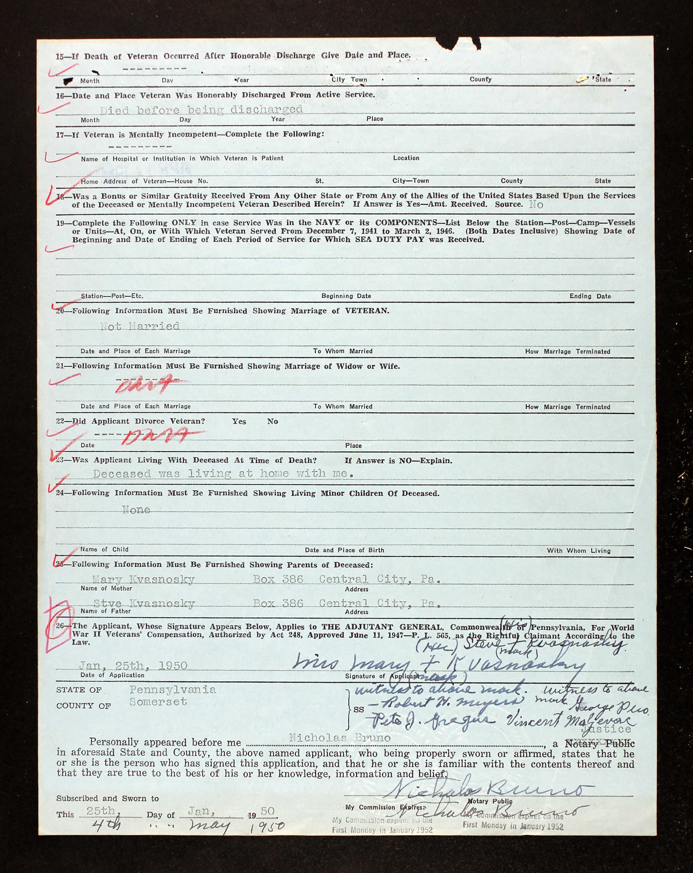

1920 Census
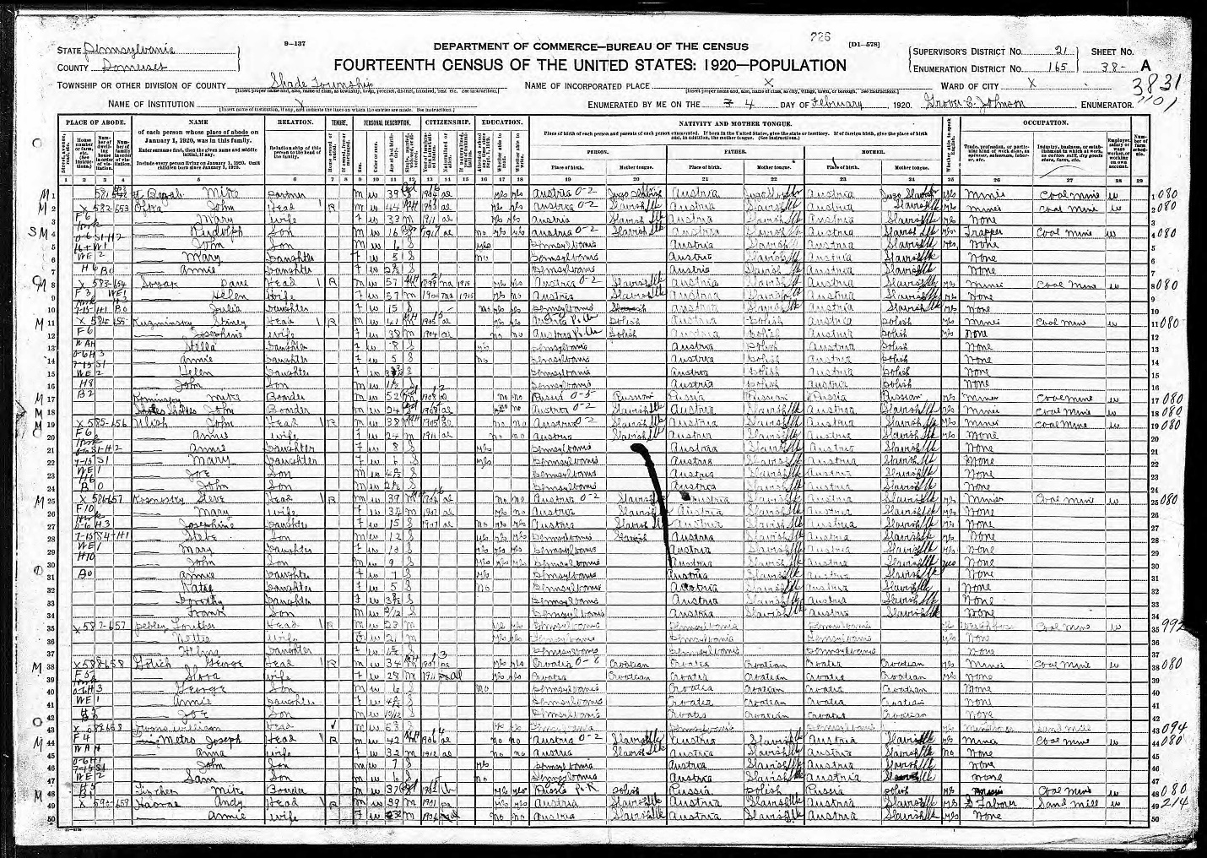

1930 Census
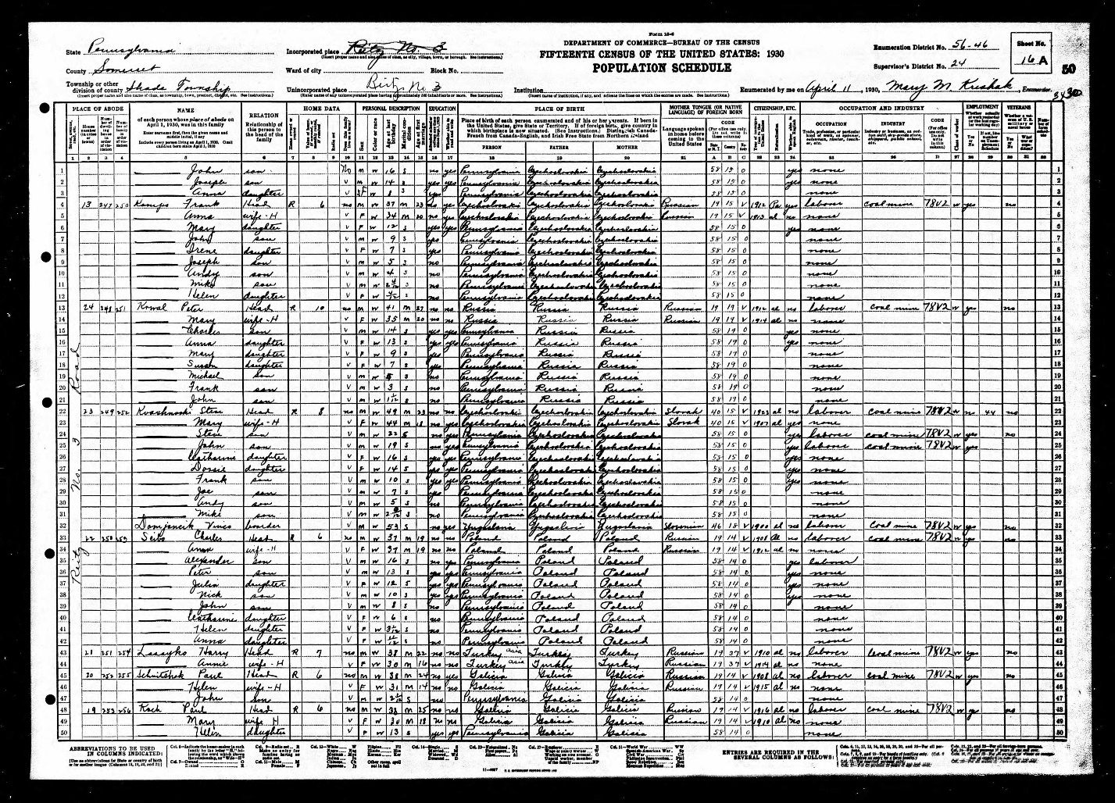

1940 Census
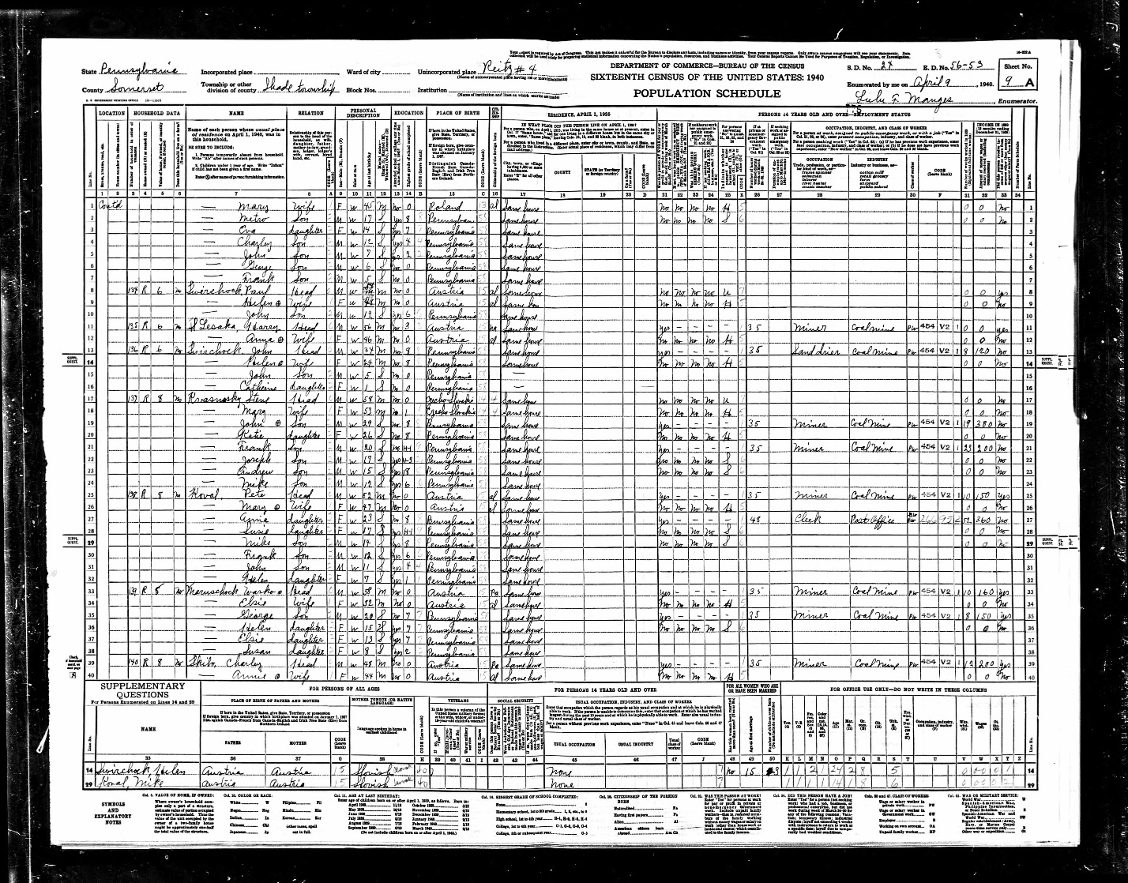

The Daily Courier, Connellsville, PA
August 9, 1944

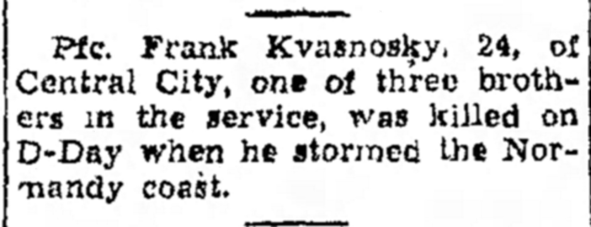

The Daily Courier, Connellsville, PA
December 2, 1947
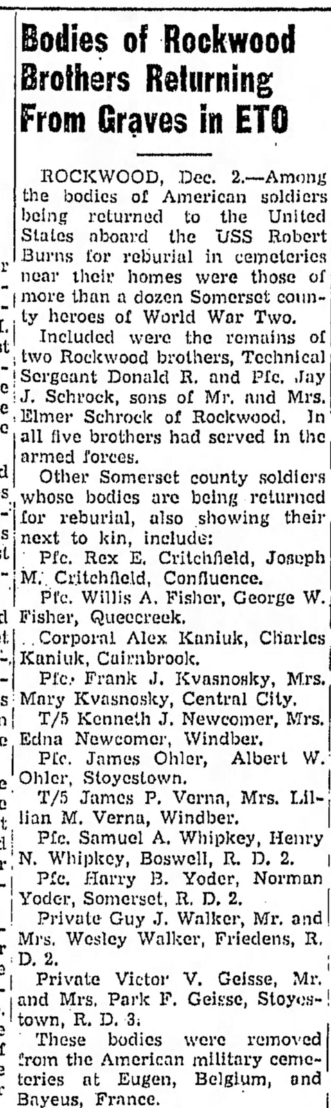

The Daily American
Somerset, PA, November 9, 2000
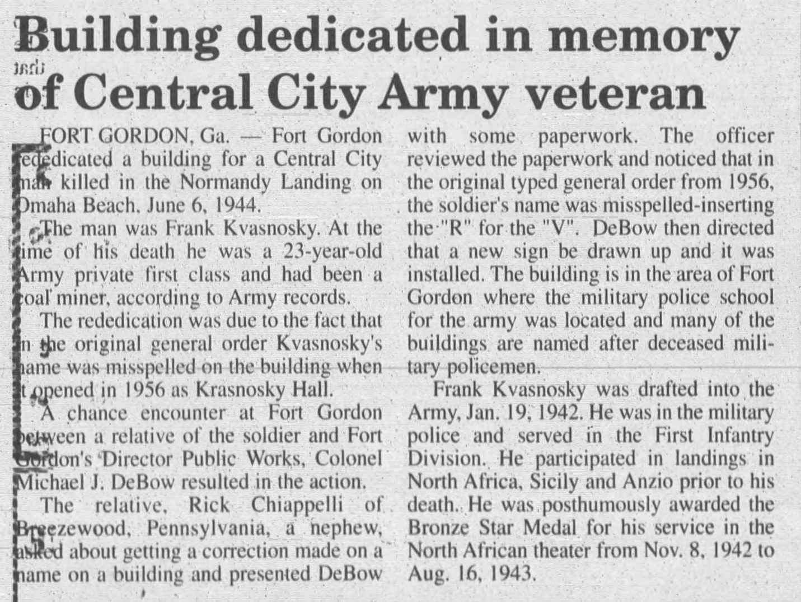

The Daily American
Somerset, PA, November 19, 2000
